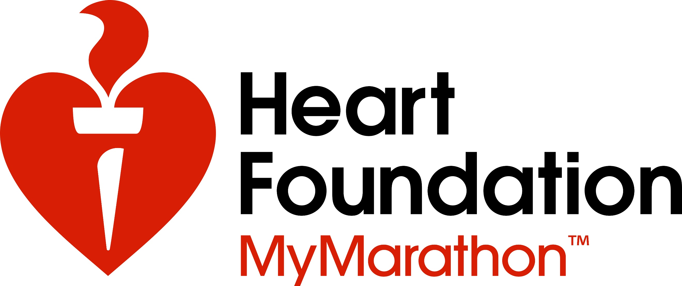
This October I’m running a marathon to fight the single biggest killer of Australians – heart disease.
Donate to my challenge
www.mymarathon.com.au

